**DIGITAL NURTURE- 4.0 JAVA FSE DEEPSKILLING**

**WEEK-1**

**ENGINEERING CONCEPTS**

**DESIGN PATTERNS AND PRINCIPLES**

**Exercise 1: Implementing the Singleton Pattern**

**CODE:**

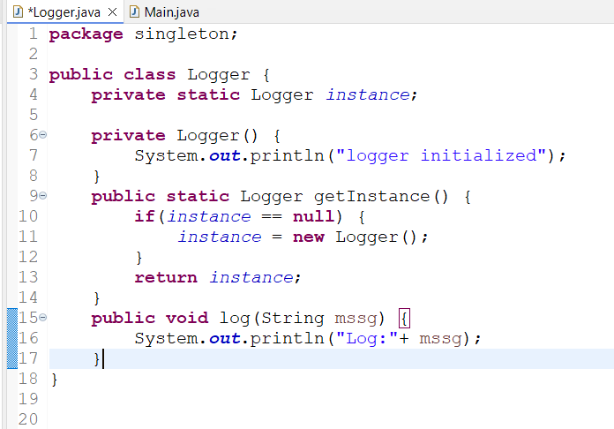

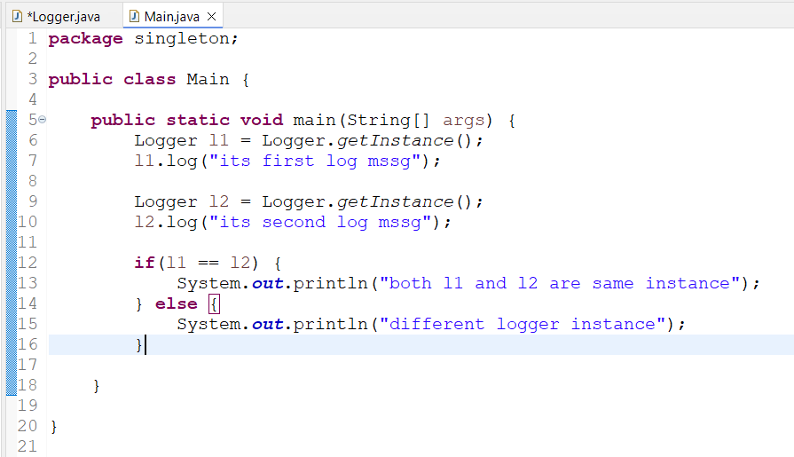

**OUTPUT:**

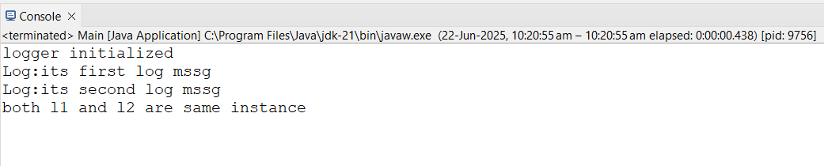

**Exercise 2: Implementing the Factory Method Pattern**

**CODE:**

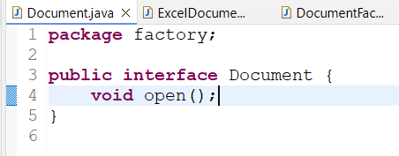

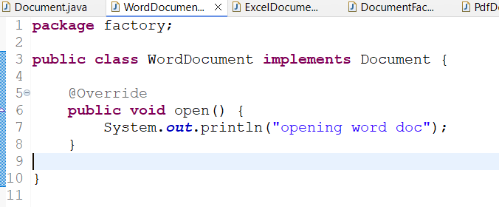

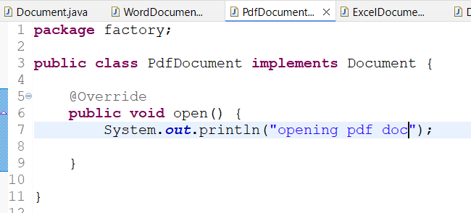

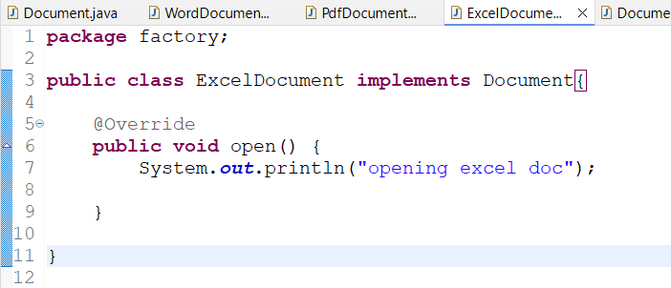

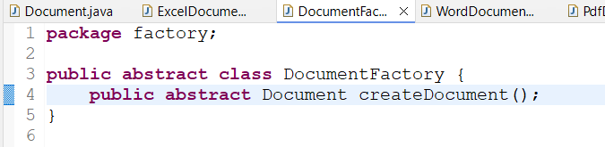

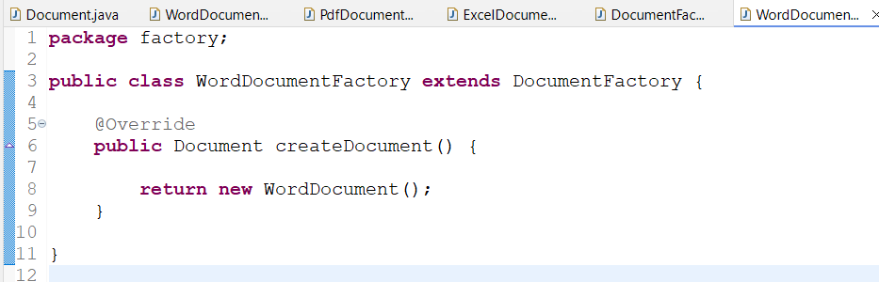

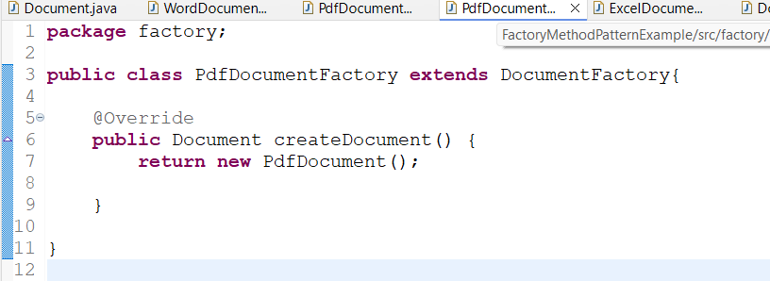

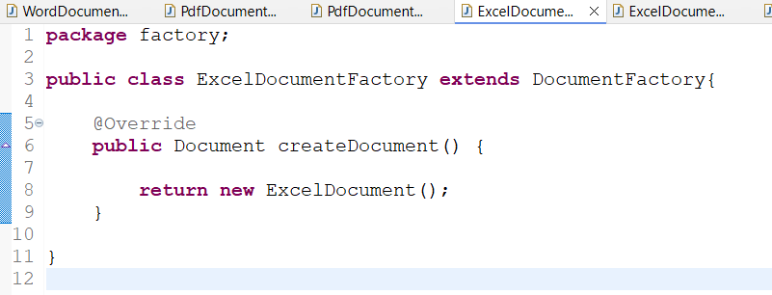

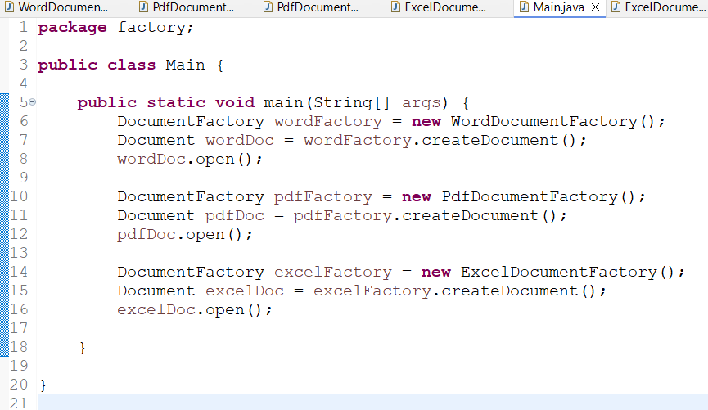

**OUTPUT:**

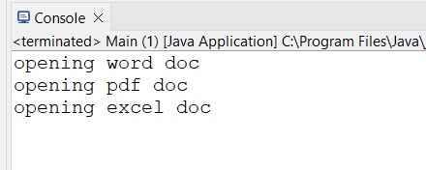

**SUBMITTED BY:**

**Name – Manjeet Swaroop**

**Superset ID: 6393474**

**Email:** [**manjeet.swaroop@gmail.com**](mailto:manjeet.swaroop@gmail.com)

**Course: DIGITAL NURTURE 4.0 JAVA FSE**